CMSC203 Assignment 3 Documentation

Class: CMSC203 CRN 20813
Program: Assignment 3
Instructor: Ahmed Tarek
Summary of Description: Implementing encryption and decryption methods
Due Date: 10/29/2025
Integrity Pledge: I pledge that I have completed the programming assignment independently.
I have not copied the code from a student or any source.
Student Name: Yonatan Rubin

Part1: Pseudo Code: Here is a pseudo code for Assignment 3 program:
isStringInBounds
1. SET result to true
2. FOR each character in the given text
3. IF the character is before the lower allowed symbol OR after the upper allowed symbol THEN
4. SET result to false
5. ENDIF
6. END FOR
7. RETURN result
end isStringInBounds

caesarEncryption
1. IF the text is not within bounds THEN
2. RETURN an error message
3. ENDIF
4. SET the effective shift to the given shift amount wrapped within the allowed range
5. SET the output text to empty
6. FOR each character in the text
7. COMPUTE its index relative to the lower allowed symbol
8. COMPUTE the shifted index as index plus effective shift wrapped within the range
9. COMPUTE the new character from the shifted index
10. APPEND the new character to the output text
11. END FOR
12. RETURN the output text
end caesarEncryption

caesarDecryption
1. IF the encrypted text is not within bounds THEN
2. RETURN an error message
3. ENDIF
4. SET the effective shift to the given shift amount wrapped within the allowed range
5. SET the output text to empty
6. FOR each character in the encrypted text
7. COMPUTE its index relative to the lower allowed symbol
8. COMPUTE the shifted index as index minus effective shift wrapped within the range
9. COMPUTE the new character from the shifted index
10. APPEND the new character to the output text
11. END FOR
12. RETURN the output text
end caesarDecryption

vigenereEncryption
1. IF the text or the keyword are not within bounds OR the keyword is empty THEN
2. RETURN an error message
3. ENDIF
4. SET the output text to empty
5. SET keyword length to the number of characters in the keyword
6. FOR each position in the text
7. LET the text character be the character at this position
8. LET the keyword character be the character at (position MOD keyword length)
9. COMPUTE the shift amount as keyword character minus the lower allowed symbol
10. COMPUTE the index of the text character
11. COMPUTE the shifted index as index plus shift amount wrapped within the range
12. COMPUTE the new character from the shifted index
13. APPEND the new character to the output text
14. END FOR
15. RETURN the output text
end vigenereEncryption

vigenereDecryption
1. IF the encrypted text or the keyword are not within bounds OR the keyword is empty THEN
2. RETURN an error message
3. ENDIF
4. SET the output text to empty
5. SET keyword length to the number of characters in the keyword
6. FOR each position in the encrypted text
7. LET the encrypted character be the character at this position
8. LET the keyword character be the character at (position MOD keyword length)
9. COMPUTE the shift amount as keyword character minus the lower allowed symbol
10. COMPUTE the index of the encrypted character
11. COMPUTE the shifted index as index minus shift amount wrapped within the range
12. COMPUTE the new character from the shifted index
13. APPEND the new character to the output text
14. END FOR
15. RETURN the output text
end vigenereDecryption

shiftCharacter
1. COMPUTE the character index by subtracting the lower allowed symbol from the character
2. COMPUTE the shifted index by adding the shift amount, adding the range, and wrapping the result within the range
3. COMPUTE the resulting character by adding the lower allowed symbol to the shifted index
4. RETURN the resulting character
end shiftCharacter

playfairEncryption
1. IF the text is not within bounds THEN
2. RETURN an error message
3. ENDIF
4. CREATE the Playfair matrix using the key
5. IF the length of the text is odd THEN
6. ADD a space to the end of the text
7. ENDIF
8. SET the result to empty
9. FOR each pair of consecutive characters in the text
10. ENCRYPT the pair using Playfair rules
11. APPEND the encrypted pair to the result
12. END FOR
13. RETURN the result
end playfairEncryption

playfairDecryption
1. IF the encrypted text is not within bounds THEN
2. RETURN an error message
3. ENDIF
4. CREATE the Playfair matrix using the key
5. SET the result to empty
6. FOR each pair of consecutive characters in the encrypted text
7. DECRYPT the pair using Playfair rules
8. APPEND the decrypted pair to the result
9. END FOR
10. RETURN the result
end playfairDecryption

buildPlayfairMatrix
1. CREATE an 8 by 8 empty matrix
2. MARK all characters as unused
3. SET the current matrix position to the first cell
4. FOR each character in the key
5. IF the character is not marked as used THEN
6. PLACE the character into the current matrix position
7. MARK the character as used
8. MOVE to the next position in the matrix
9. ENDIF
10. END FOR
11. FOR each character in the allowed alphabet sequence
12. IF the character is not marked as used THEN
13. PLACE the character into the current matrix position
14. MARK the character as used
15. MOVE to the next position in the matrix
16. ENDIF
17. IF the matrix is full THEN
18. STOP filling
19. ENDIF
20. END FOR
21. RETURN the filled matrix
end buildPlayfairMatrix

findPosition
1. FOR each row of the matrix
2. FOR each column of that row
3. IF the cell contains the desired character THEN
4. RETURN the row and column as the position
5. ENDIF
6. END FOR
7. END FOR
8. RETURN nothing (this should never occur)
end findPosition

preparePlayfairText
1. IF the length of the text is odd THEN
2. ADD a space character to the end of the text
3. ENDIF
4. RETURN the updated text
end preparePlayfairText

encryptPair
1. FIND the row and column of the first character in the matrix
2. FIND the row and column of the second character in the matrix
3. IF both characters are in the same row THEN
4. REPLACE each character with the one immediately to the right
5. WRAP around to the start of the row if necessary
6. ELSE IF both characters are in the same column THEN
7. REPLACE each character with the one immediately below
8. WRAP around to the top of the column if necessary
9. ELSE
10. REPLACE each character with the one in the same row but the column of the other character
11. ENDIF
12. RETURN the resulting two characters
end encryptPair

decryptPair
1. FIND the row and column of the first encrypted character
2. FIND the row and column of the second encrypted character
3. IF both characters are in the same row THEN
4. REPLACE each character with the one immediately to the left
5. WRAP around to the end of the row if necessary
6. ELSE IF both characters are in the same column THEN
7. REPLACE each character with the one immediately above
8. WRAP around to the bottom of the column if necessary
9. ELSE
10. REPLACE each character with the one in the same row but the column of the other character
11. ENDIF
12. RETURN the resulting two characters
end decryptPair

Part2: UML Class Diagram
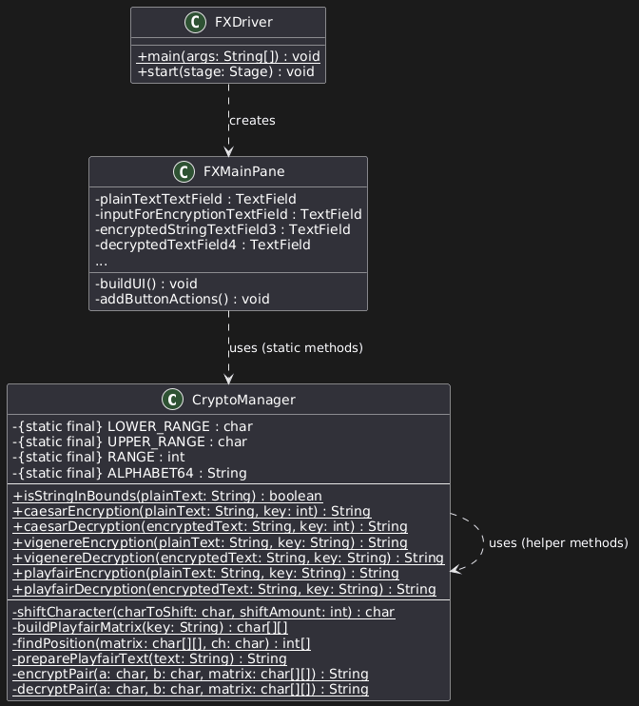

Part3: Comprehensive Test Plan
A good test plan should be comprehensive. This means you should have a few test cases that test when the input is in and out of range, division by 0, incorrect Data type, etc.(Provide valid and invalid input).
Notes:
For Design Document: Fill out only the first three columns.
For Implementation: Complete Test Plan and fill out all columns.

1 and 2 are Caeser, 3 and 4 are Vigenere, 5 and 6 are Playfair, 7 and 8 are for isStringInBounds
Cases | Input | Expected Output | Actual Output | Did Test Pass?
Case 1 | “STUDENT TEST 2025!”  key: 7 |  |  | Yes
  "Z[\\KLU['[LZ['979<("
  "Z[\\KLU['[LZ['979<("
Case 2 | Key: 7 | “STUDENT TEST 2025!” | “STUDENT TEST 2025!” | Yes
  "Z[\\KLU['[LZ['979<("
Case 3 | “STUDENT TEST 2025!”  key: “CMSC” | 6AH'(;GC72F7C_#UXN | 6AH'(;GC72F7C_#UXN | Yes
Case 4 | 6AH'(;GC72F7C_#UXN  Key: “CMSC” | “STUDENT TEST 2025!” | “STUDENT TEST 2025!” | Yes
Case 5 | “STUDENT TEST 2025!”  key: “CMSC” | “OCXHDGH6EAOC( 133#” | “OCXHDGH6EAOC( 133#” | Yes
Case 6 | “OCXHDGH6EAOC( 133#”  Key: “CMSC” | “STUDENT TEST 2025!” | “STUDENT TEST 2025!” | Yes
Case 7 | Valid String | True | True | Yes
Case 8 | Invalid string | False | False | Yes

Part4: Screenshots:

Screen snapshots of outputs from Eclipse based on your Test Plan
Test cases do not output anything
Screen snapshots of Junit Tests with extended methods’ tests
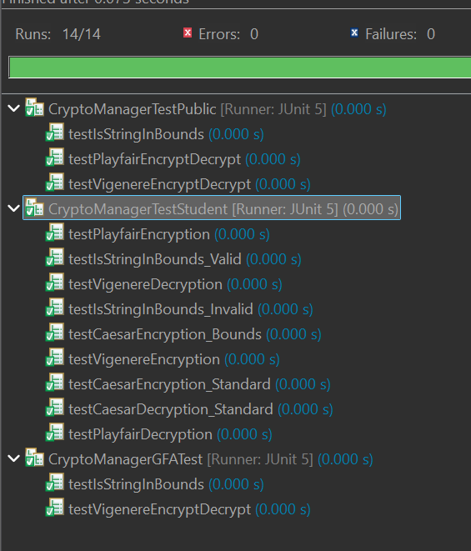
Screen shot of src folder files in your GitHub repository.
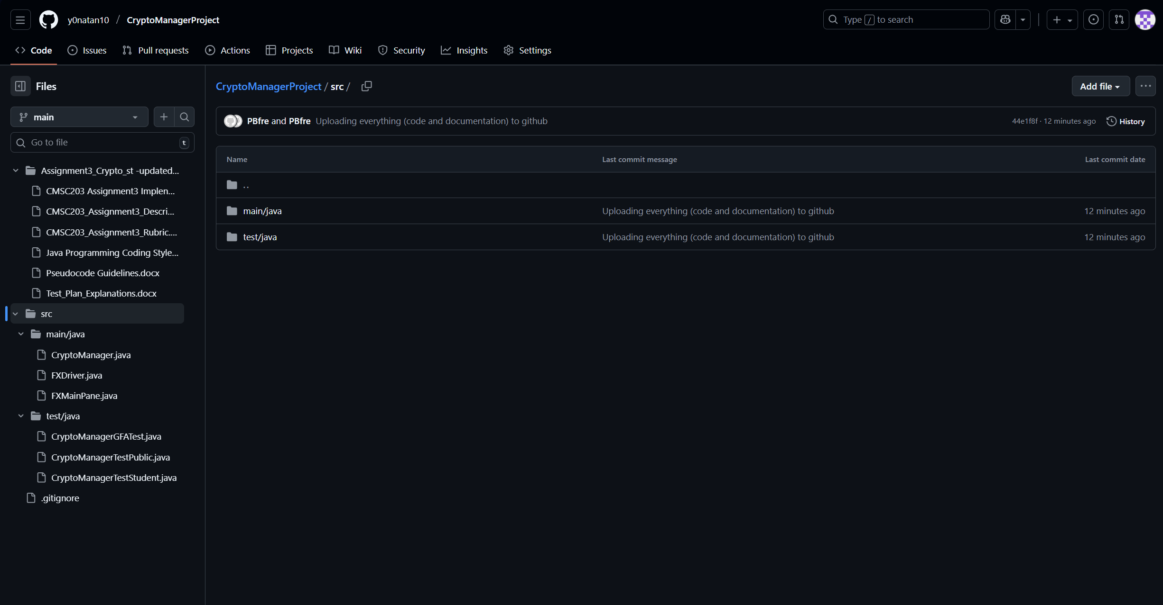

Lessons Learned <Provide answers to the questions listed above>:

Write about your Learning Experience, highlighting your lessons learned and learning experience from working on this project.

What have you learned?
I learned how to set up eclipse with JavaFX and JUnit.

What did you struggle with?
Setting up Eclipse with JavaFX and JUnit

What would you do differently on your next project?
Not use eclipse and stick with an IDE that I know will work

What parts of this assignment were you successful with, and what parts (if any) were you not successful with?
I was successful in implementing all the encryption and decryption methods as well as creating my own helper methods to make life a little easier

Provide any additional resources/links/videos you used to while working on this assignment/project.
Using plenty of AI to help me set up eclipse was the only way this project could get started
Plant UML is a godsend

Check List: <Provide answers to the column Y/N or N/A >:

# |  | Y/N
 | Assignment files:
 | FirstInitialLastName_ Assignment3_Complete.zip
 | FirstInitialLastName_Assignment3.docx/.pdf
 | Source java files
 | FirstInitialLastName_ Assignment3_JavaFiles.zip
 | Program compiles
 | Program runs with desired outputs related to a Test Plan
 | Documentation file:
 | Comprehensive Test Plan
 | Screenshots from IDE
 | Screenshots of your GitHub account with submitted Assignment# (if required)
 | Pseudocode
 | Lessons Learned
 | Checklist is completed and included in the Documentation

